Magical sensory experiences outdoors:
Caverstede Early Years Centre

URN: 110599 (Early Years Centre) and 20598 (Children’s Centre)
Area: Peterborough
Date published: 29 June 2012
Reference: 120157
Brief description

Outstanding leadership and management at Caverstede Early Years Centre ensure high-quality provision for children aged from birth to four years. Developing effective learning through sensory integration is one of the centre’s greatest achievements. In particular, the outdoor environment is continuously developed to enable children to access a rich range of sensory activities.
Overview – the centre’s message

‘As we moved more and more towards developing children’s independence through play, with an increasing focus on sensory stimuli, we realised that our fixed resources and surfaces outside were no longer fit for purpose. They weren’t accessible to all children, especially those with disabilities or additional learning needs. The children were too dependent on adults when they played outside.
We pride ourselves in providing children with high-quality – but not necessarily expensive – resources to use. Keeping parents and carers informed and involved has been a key to the successful development and use of outdoor spaces.’
Marilyn James, headteacher and children’s centre manager
The good practice in detail

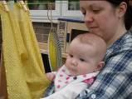
The nursery’s excellent provision has continuously developed over many years and leads to outstanding outcomes for children. When the children’s centre opened, this provided an opportunity to re-think and develop the outdoor provision. Staff were keen to contribute and take responsibility for specific areas outside to ensure their maintenance and quality. They wanted to ensure that the provision was suitable for children of all ages and stages of development, including children with disabilities and those with special educational needs. ‘We thought through progression carefully’, says Marilyn. ‘This prompted us to transform spaces at the front of the building, which had never been used for play previously, to make special places for babies, tots and children to meet and share with their parents and carers.’
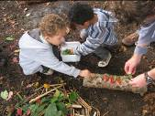
The outdoor provision takes the concept of a ‘sensory garden’ and expands it into a stunning ‘sensory environment’ for learning through play. Children’s unique sensory preferences are identified and used to plan their learning. Staff find that when children’s sensory needs are met they learn and behave well.
Reflection and evaluation are continuous and involve everyone including staff, parents and carers, and health professionals. The environment evolves around the children’s preferences and needs. Every metre of available outdoor space within the centre’s boundary is used. Children have access to outdoor play every day, at weekends and in holiday periods. Three gardens designed for specific age groups and the woodland area provide magical and challenging spaces for exploration. Each garden and resource is carefully designed and planned around knowledge about the children and families using them.
The great outdoors
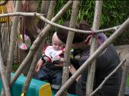
‘Developing parents’ and carers’ understanding of the importance of outdoor play and its link to behaviour has, at times, been challenging. Persuading them that outdoor play is desirable even in inclement weather has not been easy.’ says Marilyn.
The team has overcome this potential barrier in a number of ways. Investment in good-quality outer clothing and footwear keeps children warm and dry in all weathers. Woodland days are advertised in advance so that parents and carers can dress their children appropriately. A short film shows how children explore the spaces, before centre staff introduce parents and carers to the garden in pairs and guide them on how to use it. They can then pick up effective, low-cost ways to stimulate their children’s senses such as a herb tray for babies to smell and taste, or a washing line hung with fascinating shiny materials and objects at just the right height to capture the attention of very young babies.
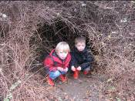
Children learn how to dress appropriately for play and how to access and use the facilities independently. This means that when any relative comes along to play alongside their children, the children lead the play. They show the adults what they want to do; they find and organise their own resources. Parents and carers are under no pressure, they simply join in, and daily learning is shared with them. Displays, photographs and finished pieces show them what their children have been doing. The centre provides literature in different languages explaining the outdoor learning policy and sensory integration.
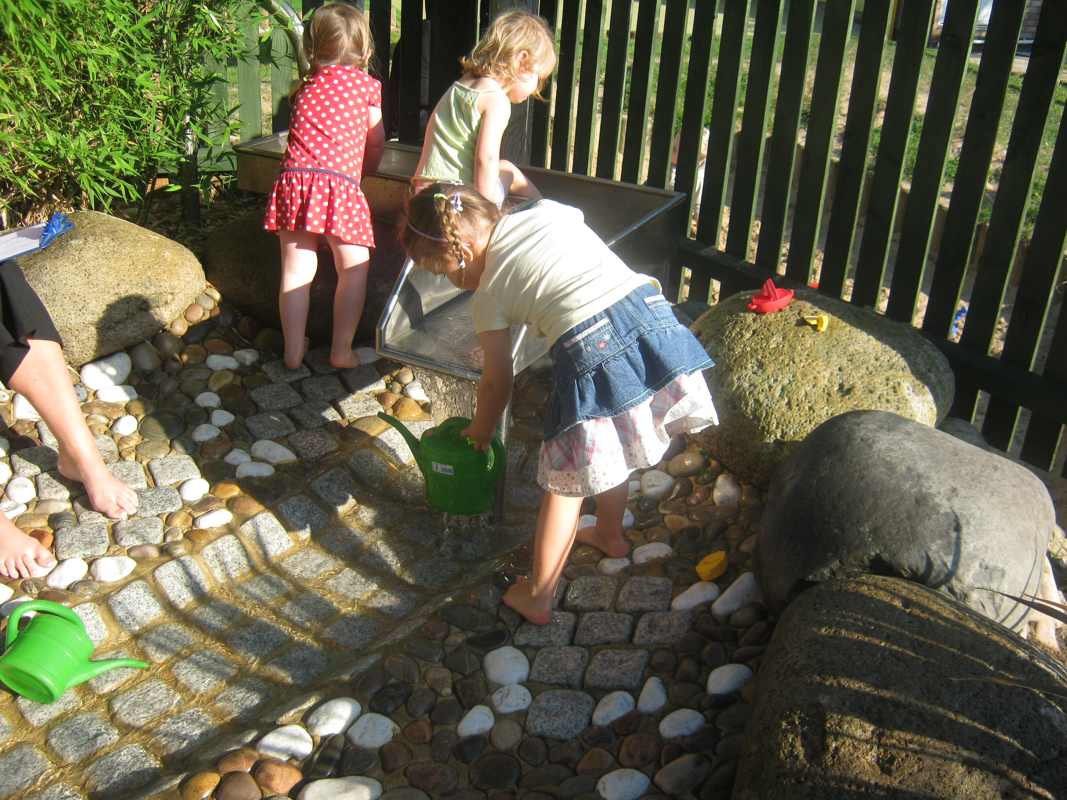
Children and their parents and carers are always prepared for what is coming next. Inside spaces have windows positioned perfectly so that children can look out and see what is going on outside. Dens and structures created from natural materials allow children to observe others playing from a position of safety and security. The least confident watch others before making the decision to join in, or not. The provision changes with the seasons but parents and carers and childminders confirm that their children always want to play outdoors. Staff generate ideas for creative new features from their observations of children at play so nothing stays the same for long.
Recent additions include an enticing water-play resource, the woodland garden for interaction with natural materials and the astro-turf area which provides ‘grassy’ mounds for energetic play or simply to lie on and watch the world go by.

Centre background

Caverstede Early Years Centre comprises a large maintained nursery school and a children’s centre serving a wide reach area in Peterborough. The nursery has 40 part-time places for children with disabilities and those with special educational needs.
Are you thinking of putting these ideas into practice; or already doing something similar that could help other providers; or just interested? We'd welcome your views and ideas. Get in touch here.
To view other good practice examples, go to: www.ofsted.gov.uk/resources/goodpractice

