Taking problem solving, reasoning and numeracy into the great outdoors: Farley Nursery School

URN: EY330201
Local authority: Wiltshire
Date published: 24 April 2012
Reference: 120047
Brief description

Children at Farley Nursery School spend much of their day exploring outside where imaginative activities are planned to develop their problem-solving, reasoning and numeracy skills. Using the outdoor space gives children excellent opportunities to explore concepts such as distance and height, which are more limited indoors.
Overview – the Nursery’s message

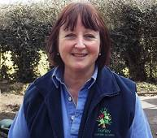
‘All you need is a little outdoor space for a few crates, drainpipes, guttering and bowls of water. The children learn so much more outside because they have more freedom to experiment, explore and discover. They are in charge of their own learning. We provide the different equipment and they work out what they can do with it. It doesn’t have to be expensive and some items, such as pallets, are free. We find that activities outdoors provide more opportunities to explore mathematical ideas and successfully engage those who learn better in this environment.’
Sue Palmer, Principal
The good practice in detail

Farley Nursery School has embraced an ‘outdoor learning’ ethos whereby children spend most of their time outside. It is therefore important that planning for activities and the range of resources available cover all areas of learning. Staff at the nursery have been focusing on developing the outdoor provision for problem solving, reasoning and numeracy. As a result, a stimulating range of resources is available to allow children to experiment and solve problems and develop early mathematical skills. Staff see great benefits for children, who are fascinated by working things out and experimenting. As one member of staff says: ‘It’s too easy to do things indoors. You need someone with a driving force to say ‘‘let’s take it all outside’’. Everything we do outside lends itself to problem solving.’
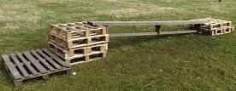
Children develop their understanding of shape and space as they take part in regular ‘big builds’. Working with staff they design and build play structures using materials such as pallets, planks, crates and tyres. They work out the best and safest way to put them together and can adapt them at any time. Most of the materials are free and easily available.
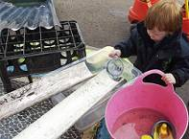
Cheap and unusual resources are used by the children to solve problems. Water, as ever, is a big hit! Children run it down guttering and drainpipes to see where it will go and use a diverse range of containers and utensils. They use items such as tin cans with holes pierced in the bottom, plastic measuring jugs, plastic spray bottles and various plumbing pipes and joints. They become engrossed in working out why the spray bottles won’t work when there is glitter in the water and spend a lot of time taking them apart, checking them and putting them back together again.
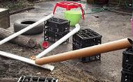
The mud pit allows children to use water on a larger scale. They use a hosepipe, crates, pipes and guttering to direct the water on to the soil and then use tools to dig and explore the properties of mud. The area is only small but children enjoy experimenting there and, since they are clothed appropriately, it doesn’t matter how dirty they get.
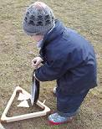
Activities make the best use of the outdoor environment. A pancake ‘shape’ race engages children by linking racing and a matching activity. Staff prepare the activity by cutting pancakes into simple shapes, using large, everyday objects of the same shape. The children take it in turns to run with their shaped pancake in a frying pan and find the corresponding shape at the end of the course. It is successful because all children are fully engaged and staff support the activity by asking children to identify the different shapes.
Older children are excited by an activity using an air-powered rocket. They take it in turns to stamp on the foot pump which powers the rocket. They discuss how high the rockets go and whose rocket has gone the furthest. They talk about the different ways in which they could measure the distance, such as by counting the number of steps as they walk. They then use a giant tape measure to find out exactly how far each rocket has gone and staff help them to record the results.
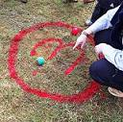
Babies and younger children enjoy simple activities that can easily be taken outdoors. Babies explore empty packets and plastic containers that are of different sizes and shapes, while staff use words such as ‘big’ and ‘small’. Toddlers’ shoes are placed in a heap on a mat and the children are encouraged to match them into pairs. The toddlers proudly find one of their own shoes and then find the matching one. There are lots of numerals on display outside. For example, powder paint is used to paint large numbers on the grass for ball games, mirrored numbers are hung from bushes and laminated, and numbered hedgehog shapes are used in the sandpit. Simple but effective ways to help children recognise numerals and learn about number values.
The Nursery’s background

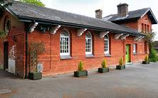
Farley Nursery School is situated in a former school building in a small village, just outside Salisbury. It has an ‘outdoor learning’ ethos and children of all ages spend most of the day outside. The nursery was judged outstanding in all areas at its previous inspection.
Are you thinking of putting these ideas into practice; or already doing something similar that could help other providers; or just interested? We'd welcome your views and ideas. Get in touch here.
To view other good practice examples, go to: www.ofsted.gov.uk/resources/goodpractice

