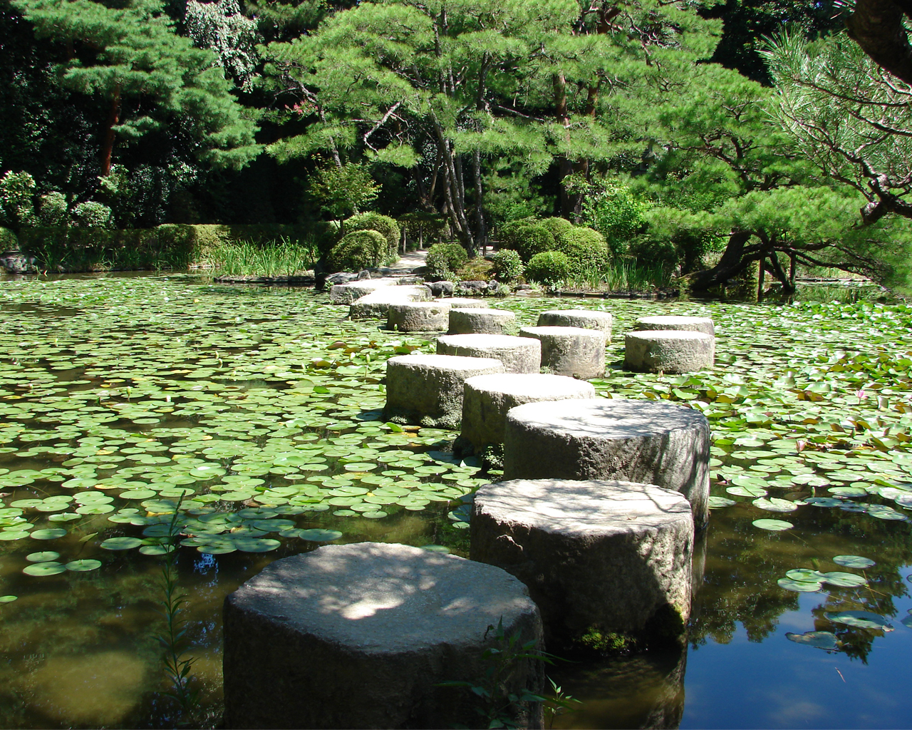
3
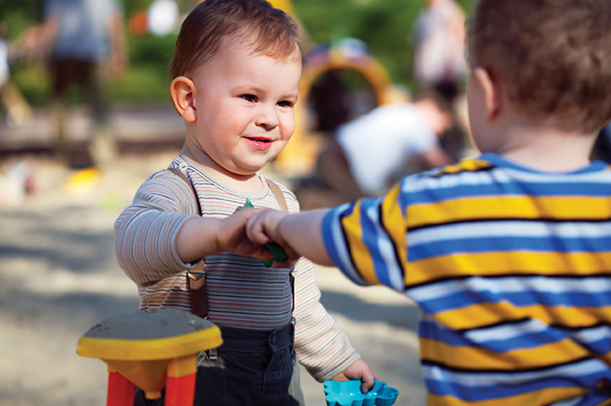
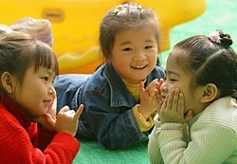
3
- A prime area of learning and key focus of the Statutory 2 year old progress check.
- Nurture a young child’s curiosity in the outdoors and maximise on the natural experiences to develop self- confidence, independence and relationships.
- The key person is vital to teaching, learning and development. These attachments support the building blocks to emotional security and positive outcomes.
- Tune into the unique characteristics of two year olds. Positively embrace their endless energy, interests and capabilities. Pause and allow time for exploring, repetition and wondering. Outdoors offer many opportunities for this best practice.
- Sensitively supported transitions which actively value the child’s perspective are crucial. Acknowledgment of the child’s unique needs, stage of development together with effective partnerships will support the process of a positive transition.

- The child monitoring tool supports the identification of a child at risk of delay.
- Actions or ‘strategies’ taken to support these areas can be recorded and evidenced on the child monitoring tool action plan. Ensure this is regularly reviewed.
- Strategies to support good practice and children at risk of delay can be found on the: Every Child a Talker website and Early Intervention Resources
- Visuals need to be part of everyday practice; indoors and outdoors. This can include using objects/actions as you talk about them. Adding gestures and signs helps understanding of language.
- Following the child’s interests; use this as a starting point to support language and communication in the natural environment.
The outdoors provides a range of rich multi -sensory experiences; this is an excellent environment which support communication at all stages of development
Personal, Social and Emotional Development
Speech, Language and Communication
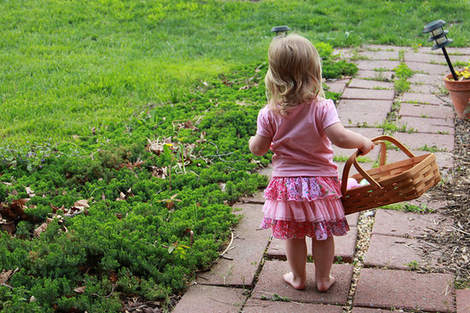
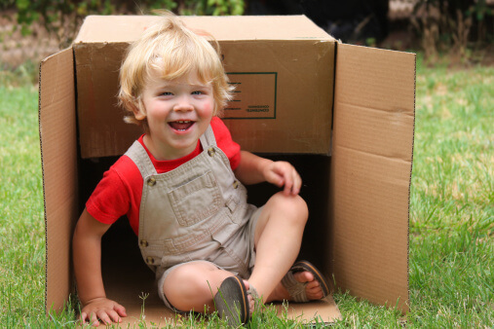
- Two year olds benefit most from access to ‘sensory-rich’ resources and experiences, for example: real fruit and vegetables to fully explore
- Children’s fascinations are often observed and can be supported by the provision of natural and open-ended resources and experiences (indoors and outdoors)
- Natural and open-ended resources and experiences also allow for the development of young children’s imagination, rather than having things ‘done for them’
- Heuristic play, as an extension of Treasure Baskets, provides two year olds with focused time to really explore natural and open-ended resources with great depth
- Natural and open-ended opportunities also extend to large scale resources and experiences which offer further challenge and chances to extend learning about themselves and the world around them

- Schemas are often also described as ‘patterns of play’ – helping children make sense of the world around them through exploration and repetition
- Schemas observed in two year olds may include: Trajectory, Orientation, Connecting, Rotation, Enclosing, Enveloping, Positioning, Transporting, amongst others
- Information about schemas is useful to share with parents to help explain children’s behaviours (which can otherwise be seen as ‘nuisance behaviours’)
- Practitioners working with two year olds should ensure that the continuous provision (indoor and outdoor) supports the development of children’s schemas
- Practitioners can support two year olds learning and development by planning for children’s individual schemas as part of provision to meet next steps tied to interests

Natural and open-ended play
Schemas
3
Gill Rogerson, IA
gill.rogerson@leics.gov.uk

Provider Helpline: 0116 305 7136
RESOURCES:
www.leics.gov.uk/ey2yearolds - information about supporting two year olds in early years provision, including audits
www.elics.gov.uk/ecat - information about supporting speech, language and communication in early years provision
www.leics.gov.uk/eyintegrated - information about the Integrated Health and Early Education Review
www.leicspart.nhs.uk/slcn-earlyinterventions - further information about supporting speech, language and communication, including age / stage related activities and strategies

Young children learning through schemas: deepening the dialogue about learning in the home and in the nursery. The Pen Green Team ISBN: 0415697328
Threads of thinking: Schemas and Young Children’s Learning. Cathy Nutbrown ISBN: 1849204640
Like bees, not butterflies: child initiated learning in the early years, Sally Featherstone ISBN: 1906029768
Again, Again! Understanding schemas in young children. Sally Featherstone ISBN: 1905019955
Stephenson, A. (2002). Opening up the outdoors: Exploring the relationship between the indoor and outdoor environments of a Centre. European Early Childhood Education Research Journal, vol.10, no.1. pp29-38.
https://www.tes.com/article.aspx?storycode=19254 – TES article entitled ‘in the schema things’
www.communityplaythings.co.uk – natural and open-ended resources, ideas and FREE training booklets
https://janwhitenaturalplay.wordpress.com/2011/12/30/meeting-the-needs-of-two-year-olds-in-outdoor-play-provision-early-years-educator-volume-12-issue12-april-2011/ - a Jan White Early Years Educator article entitled ‘Meeting the needs of two year olds in outdoor provision’ 2011
https://www.gov.uk/government/publications/teaching-and-play-in-the-early-years-a-balancing-act Teaching and Play in Early Years: a balancing act? Ofsted 2015
https://www.gov.uk/government/publications/teaching-young-children-to-develop-their-communication-skills Ofsted good practice example: Teaching Young Children to develop their Communication Skills: Nicola Phillips (child-minder) Ofsted 2015

