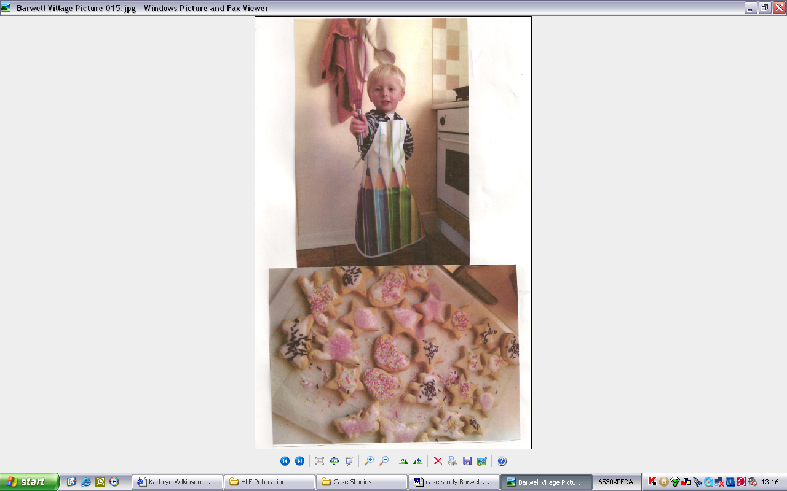
Experiences

Sharing resources between home and setting enables children to make connections in their thinking and language skills by focusing on
Case study
things that they already understand.

I put together a box that was full of all the things that you would need to make cakes and biscuits. We included simple recipes to follow, and all the basic equipment needed. It was offered to parents as they were leaving the setting after collecting their child.

We have received much positive feedback from the children. One child said, “I had a lovely time with daddy and he had never done any baking with me before”, another child baked cakes with grandma and both really enjoyed the experience!

Pictures were sent in by parents which we posted on the wall to enthuse other parents. This worked well, generating much interest and sparked conversations between children and their parents or carers, asking if they could take the chatterbox home!

Children were really excited to bring in the results of their hard work to show us… and this has been a tasty treat to share at snack time! We have also valued this at home learning by including photos and comments from parents in the children’s learning journeys. This has created such a buzz in the setting, with children looking at one another’s photos and talking to each other about their cookery experiences.

We wanted to make sure this was accessible to our vulnerable parents, particularly those hard to reach who may choose not to engage through embarrassment if they could not afford to purchase the ingredients. Key workers approached targeted parents sensitively and discreetly with the offer of filling the chatterbox with everything they would need. This enabled them to benefit from the experience and provide valuable input for their child.

This has been so successful that we have been inspired to try out new ideas for different boxes including a bug box!

Barwell Village Hall have been cooking up a twist on the chatterbox theme.

Ann takes us through the ingredients that helped to make the project a success…

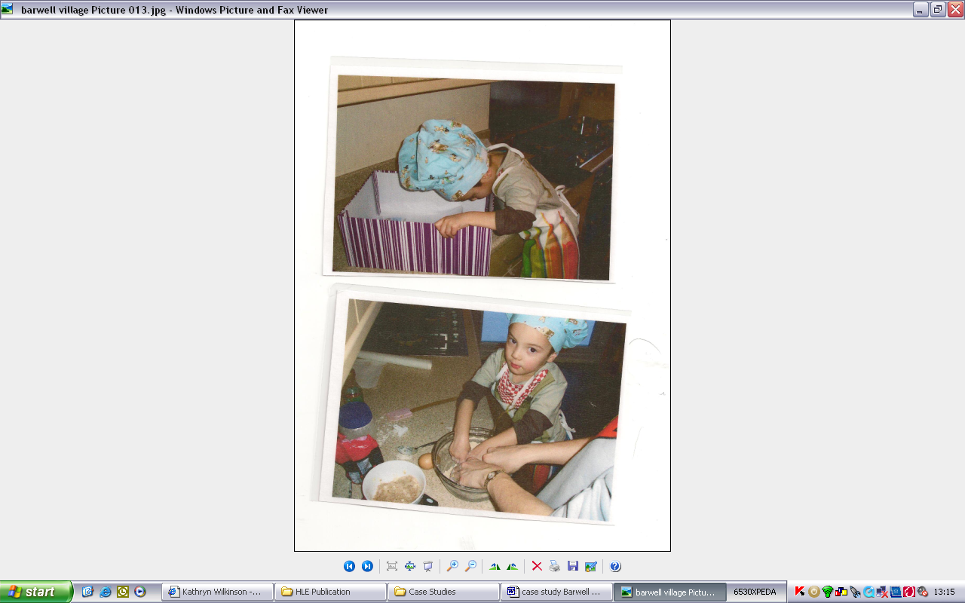

relationships attachment interactions
relationships attachment interactions
The key person role

It is essential to know your individual families and target support. The key person’s role is crucial in making sure parents understand the prompts on the box lid. Some verbal explanation and a simple example may support this:
“mixing”
“yes, that’s right, you are mixing with the spoon”

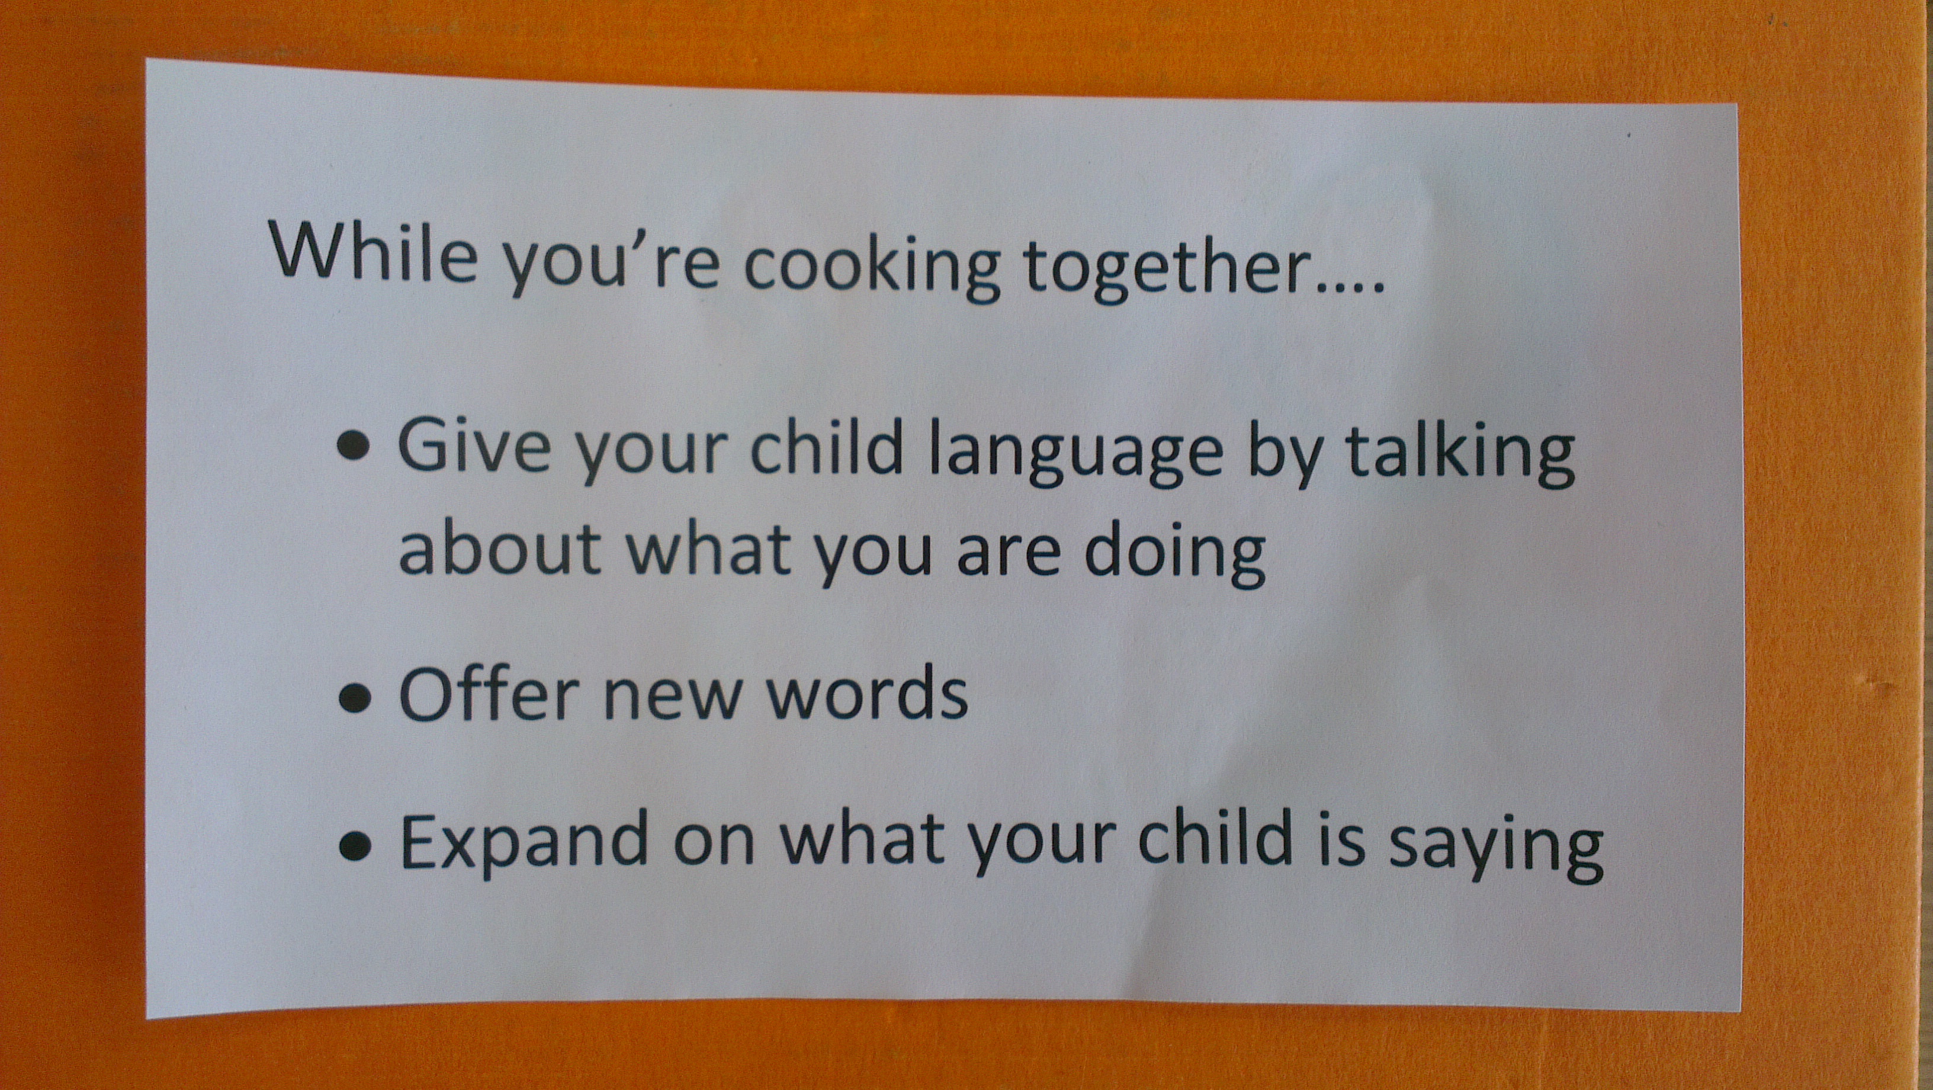

Further ideas…
- You might send out this chatterbox to coincide with special family events, for example birthdays or festivals and other celebrations.
- Why not try aiming the chatterbox at other family members, for example Aunts and Uncles, Grandparents… but be sure not to exclude any children who might not have relatives who live close by.
- Look out for easy ‘non cook’ recipes to support parents who may not be confident in the kitchen.

Reflecting on practice:

How would you introduce this idea to your parents?

How would you encourage vulnerable families to participate?

Remember – playing with letters and numbers with your child is one of the key activities to stretch a child’s mind.
Ideas to share with parents might be to:
Look at recipe card with your child
Count the spoonfuls of each ingredient
Look at letters and numbers on the ingredients

Remember… research suggests that practitioners should share with parents the importance of the following:

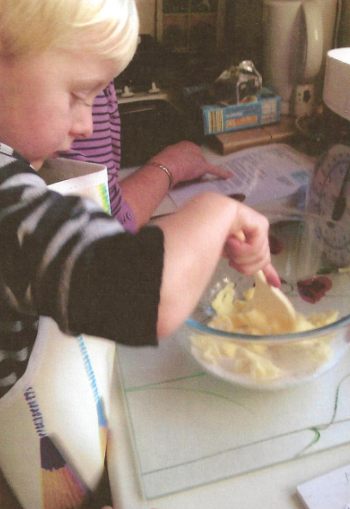
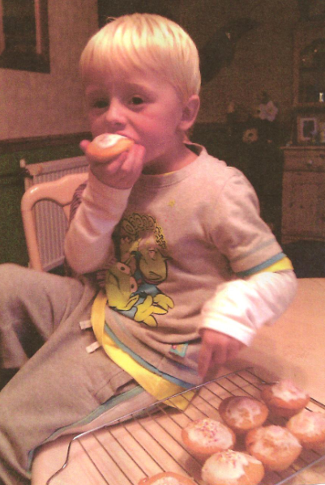
Listening to children; engaging in sustained, shared thinking – reasoning, speculating, describing, making connections and questioning.
Providing real experiences; including the child in everyday routines. Learning through action and making sense.

activities experiences opportunities stimulation
How do you share these key messages with parents?

