Opportunities

Developing a life long love of reading starts with sharing a good book.
Case Study
We decided to use the Story Sack idea, which was really worth doing as it has got children and parents spending precious time reading and playing together.
Children are able to take the Story Sacks home to use as a family and we have incorporated a range of books to promote reading for a range of purposes. For example the ‘story’ sacks might include: story books, non-fiction books, nursery rhyme or poetry books, books from a variety of cultures and reflecting a range of different experiences.
For our families for whom English is an Additional Language (EAL) we have provided dual-language books and encourage parents to access their child’s ‘Bookstart pack’, which is available in a variety of languages.
Both parents and children have said how much they have enjoyed the Story Sacks and explained how they have set aside special time to do them. We have also consulted with parents to find out about different Story Sacks they might appreciate: this included ‘moving house’, ‘new shoes’, and ‘dentist appointment’.
As a team we have made a conscious effort to provide Story Sacks which support individual children’s interests, and include resources and props to extend their understanding in certain areas. For children interested in dinosaurs for example, we have a story sack which includes: ‘Harry and his bucket full of dinosaurs’ and figurine dinosaurs featured in the story, a non-fiction ‘Dinosaur facts’ book, some ‘fossils’, a magnifying glass and an archaeologists notebook; because of this our children come into Pre-School telling us about what they have been doing at home and which bag they want to borrow next!

Through this project we have
confirmed to ourselves how essential
it is to have an understanding of how
to promote our resources to parents
and the importance of regularly
checking resources and evaluating
their effectiveness.

Practitioners at Little Stars Pre-School developed a range of exciting Story Sacks to share with children and their families.

Here Emma tells us the story of how it all happened…

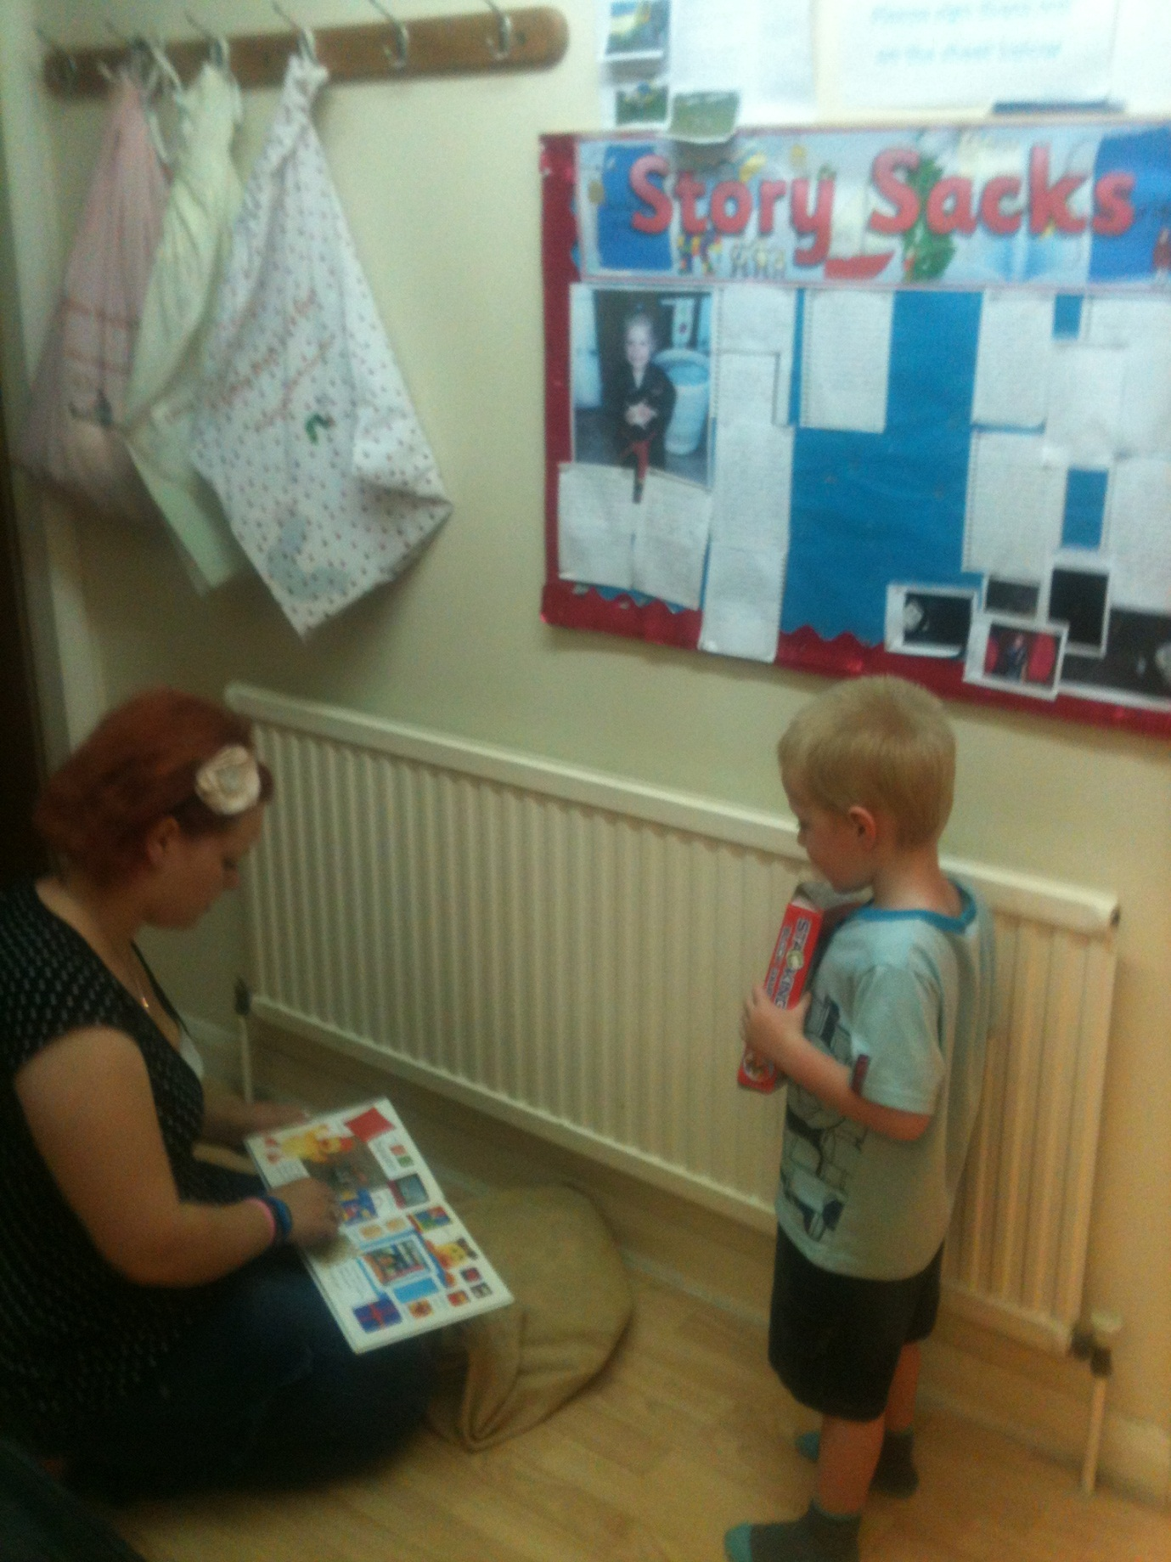

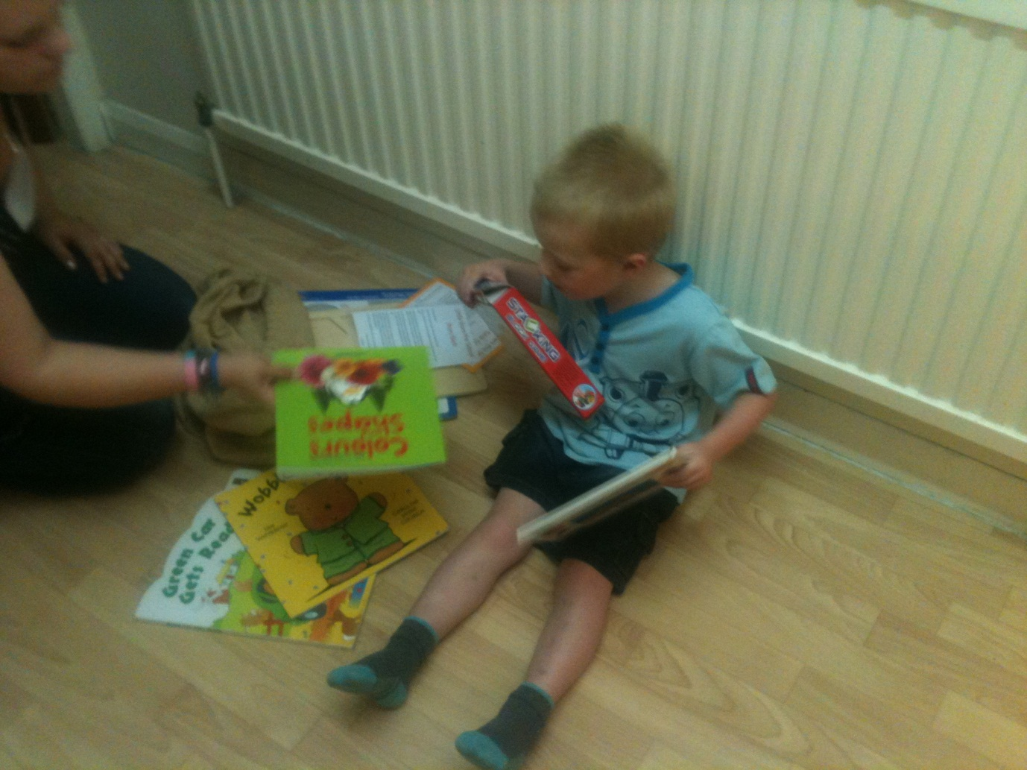

relationships attachment interactions

Key Person Role
Help parents understand the importance of learning in everyday scenarios, as well as these provided activities - suggest things they can do, such as 'reading' the shopping list or making up songs in the car. It will be necessary to tailor this support to the individual needs of families and interests of particular children.

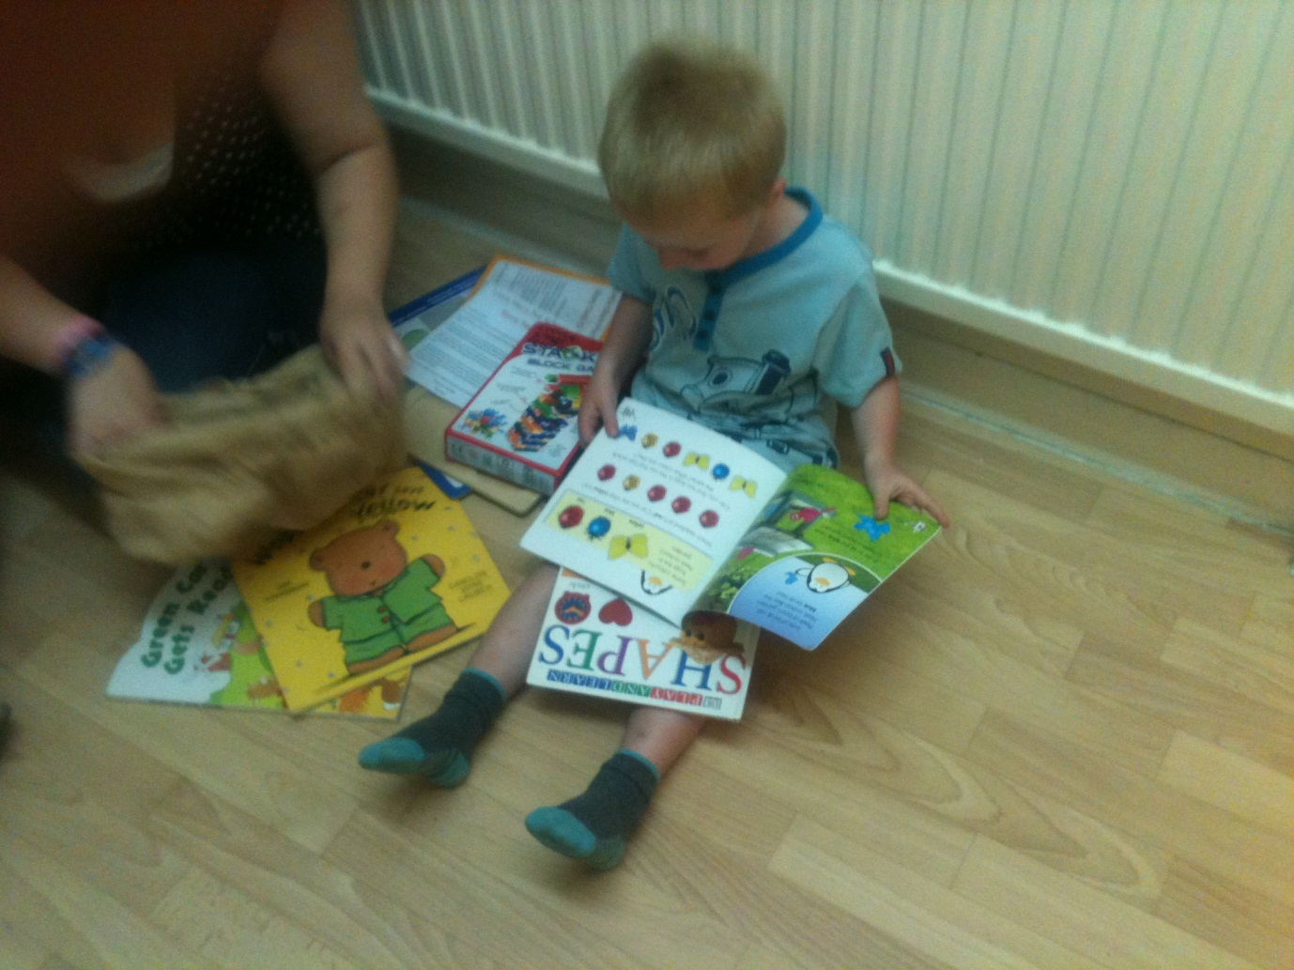
Remember…
'Reading with and to children' is one of the key activities to 'stretch a child's mind'. Be prepared to explain to parents why their child enjoys looking at the same book over and over again! Talk to them about how children learn and what they are gaining from this valuable experience.
activities experiences opportunities stimulation
Remember… Research suggests that practitioners should share with parents the importance of the following:
Developing an understanding of letter sounds and patterns.
Knowing that growing up bilingual gives positive social and cognitive outcomes.
Reflecting on practice:

How do you gather information from parents and children when evaluating your practice?

How do you involve parents in creating new resources? Encouraging ownership through their input and valuing their suggestions will benefit children.

Further ideas…
- Point parents in the direction of their local library and ensure they have accessed their child's free Bookstart packs.
- Encourage parents to share positive experiences with one and other, as well as with practitioners - provide an outlet for this such as a 'what we did at home today...' display board.
Talking about words, letters and sounds in context of everyday and book experiences.
How do you share these key messages with parents?

